ConnecTeen

Community-based
Crisis Intervention

Program

Session 7 of 8

ConnecTEEN project

lyk-z & daughters as
Created by: Anne Marit Lykseth &
Hanne Marie Bratsberg

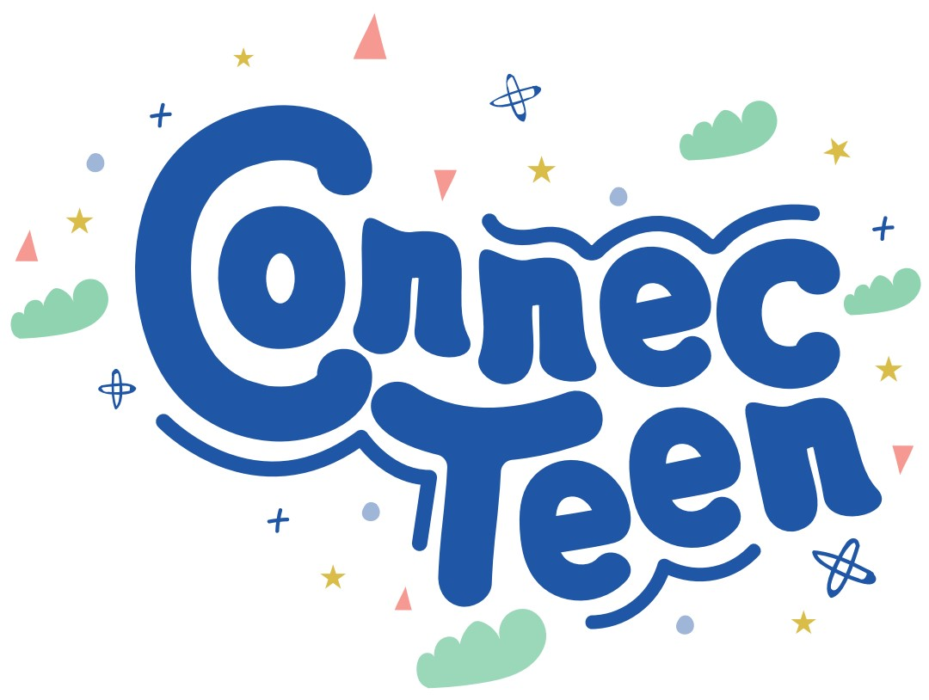

Table of Content

ConnecTeen Session 7 3
School wellbeing 3
Equipment list 3
Welcome 3
Part 1: Brainstorming School wellbeing 3
Part 2: Brainstorm Exercises 3
Part 3: Exercise School wellbeing reflections 4
Closure/Summary 4
Home assignment 5
Acknowledge the class/students 5
PARTNERS 6

ConnecTeen Session 7

School wellbeing

Goal: Inclusion and community building

Equipment list for session 7:
PC with Power Point
Projector/TV to show Power Point
Extra sheets of A4 paper
Welcome – Time: 4 mins

Trainers will say to the group:
Welcome 😊 What is something you remember from last session or want to share about your home assignment?

Today’s session provides an important opportunity to reflect on your experiences within the school environment. As we focus on the theme of school well-being, you’ll be invited to consider how your interactions, mindset, and personal growth contribute to a healthier and more positive school experience. Please engage thoughtfully and approach the session with openness and curiosity.

Part 1: Brainstorming School wellbeing – Time: 3 min
Trainers ask: What does school wellbeing mean to you?

Part 2: Brainstorm Exercises– Time: 3 min
Trainers ask: What do you remember that you have learned/explored in the previous 6 sessions?

Part 3: Exercise School wellbeing reflections– Time: 25 min
Purpose: The purpose of reflecting on school well-being is to help students become more aware of how their thoughts, behaviors, and interactions affect their everyday experience at school. By taking time to consider their relationships with teachers and classmates—as well as their own role in creating a positive environment—students can better understand what supports their well-being and what changes might help them feel more connected, motivated, and confident in the school setting.
Trainers ask the students:
How has everything you’ve learned so far affected your interaction with:”
- Your teacher(s)?
- Your classmates?
- Your overall well-being at school?

Step 1 – Individual Reflection
Ask students to take a few minutes to write their answers individually in their notebooks. Encourage honest and thoughtful reflection.

Step 2 – Small Group Sharing
Divide the class into triads (groups of three). Instruct them to:
- Share their individual reflections with one another.
- Use the "Yes, and…" technique to build on each other’s ideas, rather than debating or correcting.
- After a few minutes, work together to agree on one common conclusion that represents their discussion.
Step 3 – Class Presentations
Invite each triad to come to the front and present one key conclusion related to one of the following areas:
- Interaction with teachers
- Interaction with classmates
- Overall school well-being

Each group should choose only one area to focus on in their presentation.

Instructions for the trainers: After each group presents, acknowledge their effort with a positive comment and invite the entire class to give them a loud round of applause. This reinforces participation, confidence, and group appreciation.

Closure/Summary - Time: 3 min
You have now collaborated and shared your thoughts with others. By doing this you have automatically contributed to a more including class community.

Home assignment – Time 5 min:
Introduction for the students: Purpose of a home assignment is that if you want something new in your life, you have to do something new. When you take action between each session, change will happen.

Assignment: Make your own home assignment based on this session. Hear a few examples from the participants.

Acknowledge the class/students - Time 2 min
Find something from today’s session you can acknowledge before you say goodbye.

PARTNERS


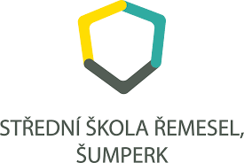




Funded by the European Union. Views and opinions expressed are however those of the author(s) only and do not necessarily reflect those of the European Union or the European Education and Culture Executive Agency (EACEA). Neither the European Union nor EACEA can be held responsible for them.

