ConnecTeen

Community-based
Crisis Intervention

Program

Session 8 of 8

ConnecTEEN project

lyk-z & daughters as
Created by: Anne Marit Lykseth &
Hanne Marie Bratsberg

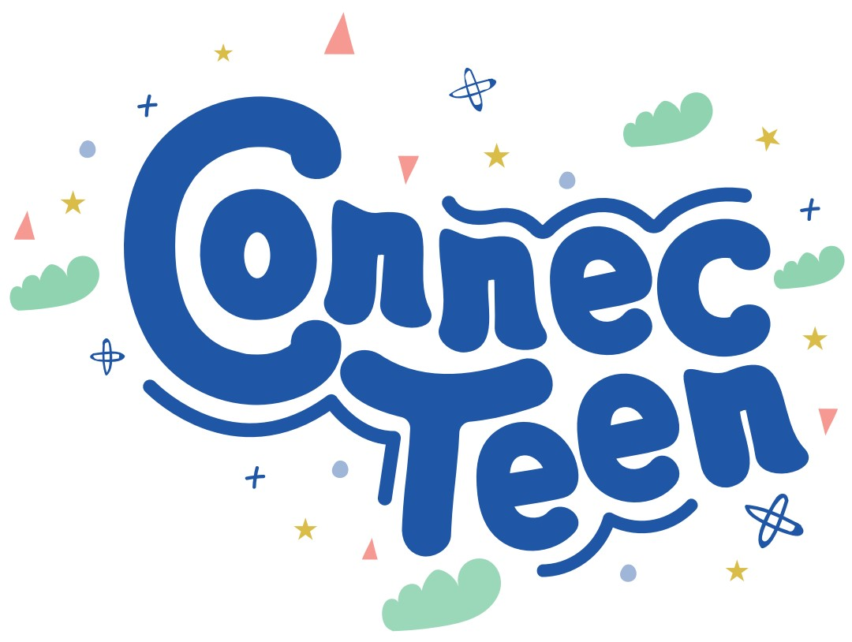
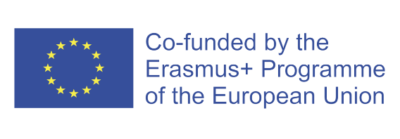
Table of Content

ConnecTeen Session 8 3
Emotional, Social, Physical and School wellbeing 3
Equipment list 3
Welcome 3
Part 1: Exercise “Superman-cape” 4
Closure/Summary 4
Home assignment 5
Acknowledge the class/students 5
PARTNERS 6

ConnecTeen Session 8

Emotional, Social, Physical and School wellbeing

Goal: Self-confidence and community building

Equipment list for session 8:
PC with Power Point
Projector/TV to show Power Point
Flipchart paper
Flipchart stand
Black/green/blue markers – one for everyone
One roll of painter’s tape
Speakers (if not via projector/pc/TV)
Pencils for the students*
Notebooks for the students*
Pencil sharpener*
*If they do not use notebooks, they will need sheets of paper
Welcome – Time: 3 mins

Trainers will say to the group:
Welcome to the final session of the ConnecTeen-program! What is something you remember from last session or want to share about your home assignment?

Although this is the final session of the ConnecTeen Program, the growth and tools you’ve gained are meant to support you far beyond today. Let this be the starting point for continued self-awareness, confidence, and connection in your everyday life.

Part 1: Exercise “Superman-cape” – Time: 27 min
Instructions for the trainers: DO NOT TELL THEM WHAT THEY ARE ABOUT TO DO UNTIL THEY HAVE A FLIP CHART SHEET ATTACHED TO THEIR BACKS. YOU as teachers WILL NOT HAVE A FLIP CHART on your back, you will only participate by adding positive things to the students’ backs.

Step 1: Every student gets one flip chart each. They can help each other to fasten it on their backs with pieces of tape. Then, they will get one marker each.

Step 2: You will then explain the first round to the students. Round 1 = write the number 1, then one acknowledging word on each other’s backs. For example: 1. Kind.
ONLY write the quality. Tell them to write on as many different backs as possible. Tell them to be generous!

Step 3: Start the music and let the round go on for about 3-4 minutes.

Step 4: Stop the music after 3-4 minutes. You will then explain round 2. A challenge (!) – write the number 2 in front of the challenge. The challenge can be based on something they have heard the other person say. Example: 2. Sing in front of the class.

Step 5: Start the music and let the round go on for about 3-4 minutes.

Step 6: Stop the music and tell the group to sit down with their flip charts in front of them.

Reflections

- All the participants place the sheet in front of them and read the feedback
- They mark a distinct circle around the one word or phrase they like the most.
- Then they will choose at least ONE challenge they are willing to do! Circle it!
- Let a handful of the class share what they have chosen.

Closure/Summary - Time: 6 min
Begin with showing the PP with all the exercises displayed.
Make a summary for the participants. Say: During these 8 sessions you have looked inward, listened to yourself and made links outward to your classmates, and with your community when you practiced your home assignments.

Then ask the class which exercise made the biggest impression. Listen to the responses. THEN ask WHY did this/these exercise(s) make such a big impression on you?

Acknowledge them for their contributions.

Home assignment – Time 2 min:
Introduction for the students: Purpose of a home assignment is that if you want something new in your life, you have to do something new. When you take action between each session, change will happen.

Assignment: Do/start on the challenge you chose from the “Superman cape”-exercise!

Acknowledge the class/students - Time 2 min
Find something from today’s session you can acknowledge before you say goodbye.

PARTNERS

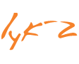
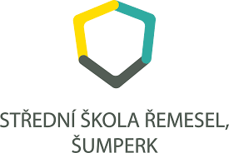

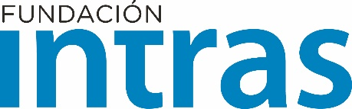
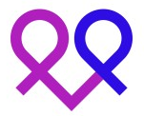

Funded by the European Union. Views and opinions expressed are however those of the author(s) only and do not necessarily reflect those of the European Union or the European Education and Culture Executive Agency (EACEA). Neither the European Union nor EACEA can be held responsible for them.

